Article Title
Author name^{1*}, Author name ², Author name³, …
¹ Affiliation…, Department…, Address …., City…(Country)
email
*contact author
^{ORCID}

²Affiliation…, Department…, Address …., City…(Country)
email
^{ORCID}

³Affiliation…, Department…, Address …., City…(Country)
email
^{ORCID}

Received: [….]
Accepted for publication: […]
Published: […]

Abstract
Sample text inserted for illustration. Replace with abstract text. Your abstract should give readers a brief summary of your article. It should concisely describe the contents of your article, and include key terms. It should be informative, accessible and not only indicate the general scope of the article but also state the main results obtained and conclusions drawn. The abstract should be complete in itself; it should not contain undefined abbreviations and no table numbers, figure numbers, references or equations should be referred to. It should be suitable for direct inclusion in abstracting services and should not normally be more than 300 words.

Keywords: …[no more than 6 keywords]

1. Introduction
Thank you for considering submitting your manuscript to our journal. To facilitate the review and publication process, we kindly ask you to adhere to the following formatting and style guidelines. Ensuring consistency across all submissions will help streamline the publication process and maintain the quality of our journal.
Sample text inserted for illustration. Replace with article text, including headings where appropriate.

1.1 Font
Please use Times New Roman, size 10, for the text of your manuscript, including the main body, references, and footnotes.

1.1.1 Reference Style
Our journal adheres to the APA 7th edition style for citations and references. Please ensure that all citations in the text and the reference list comply with this format.

1.2 Acronyms and Abbreviations
When using acronyms or abbreviations for the first time, the term should be spelled out with the abbreviation in parentheses. Subsequently, you may use the acronym alone, for example, World Health Organization (WHO).

2. Tables and Figures
Tables and figures should be embedded within the text at appropriate points, rather than at the end of the document. Each table and figure should have a concise caption describing its contents and be numbered consecutively in the text in the order of their appearance.

Table I: Title of the table
Enter the text here | Enter the text here | Enter the text here
Enter the text here | Enter the text here | Enter the text here
Enter the text here | Enter the text here | Enter the text here
Source:

Figure 1. Figure title
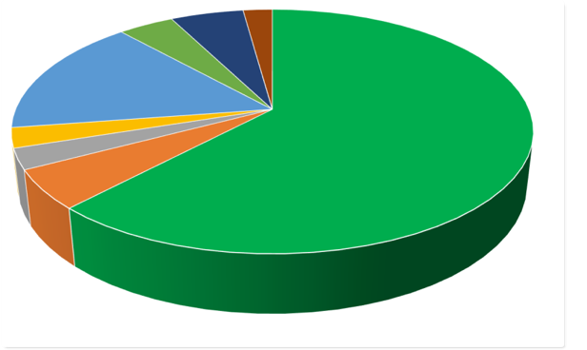
Source: Surname, N., & Surname, B. (Year). Title.

2.1 Other information
Ensure all figures and tables are cited in the text. Use the same font as the rest of the document in the preparation of figures and tables. Each should have a clear title and source listed directly beneath it.
By following these guidelines, you will assist our editorial team in efficiently processing your submission. We look forward to receiving your manuscript and thank you for adhering to these guidelines.

3. Language and Grammar
All the contribution should be submitted in English.
Ensure that your manuscript is thoroughly proofread and free of grammatical and spelling errors. This helps maintain the professional integrity of your work.

4. Conflict of Interest
A declaration of any potential conflict of interest must be clearly stated in the manuscript to maintain transparency and trust.

5. Acknowledgements
Acknowledgements should briefly recognize the contributions of those who supported the work but are not listed as co-authors. This section should be succinct and respectful.

6. References
All references must adhere to APA Style. Each reference should be cited in the text and listed at the end of your paper in alphabetical order. Properly formatted references contribute to the credibility and accessibility of your paper.
Surname, N., &Surname, B. (Year). Title. Journal’s name, 17(5-6), 519-533.

7. Additional Information
All contributions should be submitted in English. Maintain a useful subdivision using numbered sections to increase the impact on readers and improve the organization of your article. Each section should be clearly defined and contribute to the overall coherence of the paper.
Please, maintain a useful subdivision using numbers.
To increase the impact on readers, consider to divide your articles into defined sections (i.e. 1, 2, 3 and 1.1, 1.2, 1.3, and more).

7.1 Example of sections
Submitted articles should have the following sections:
- Abstract (Structured and with the identification of the aim of the sudy, the main methodology insights, and the conclusions of the article) – 300 words.
- Keywords – please provide 3-6 keywords related to your paper. They are essential for indexing purposes.
- Introduction (Structured introduction in which authors provides the positioning literature of the paper, the gap, the purpose and aim of the paper, the contribution in terms of literature and the organization).
- Literature review (in case of practical paper we would suggest authors to assess a literature review of the variables under investigation in the study).
- Methodology (This section should provide how author conducted their study. It is provided by scientific references).
- Results (This section provide the main theoretical or practical results of the study).
- Discussion (It is highly appreaciated. Particularly, this section aims to contribute summarysing and intepreting the main results achieved).
- Conclusion (This section concludes the paper considering a sum of the paper, the main contribution in terms of the literature, the main practical contribution, the limitations of the study and the future research possibilites for scholars).
- Appendices are also possibles.

