DATA ANALYSIS AND DISCUSSION

Sample Analysis: Below in figure 1 is the sample analysis in graphical representation.

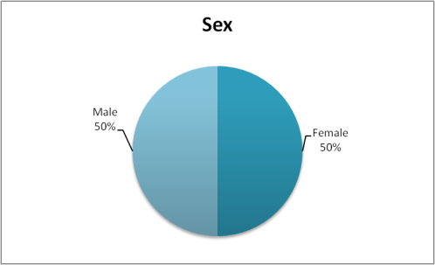 | 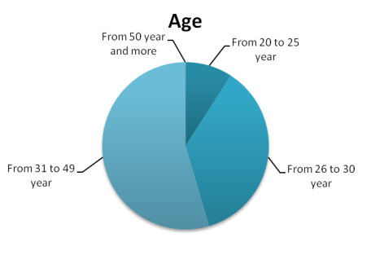
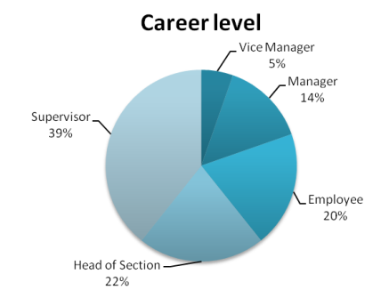 | 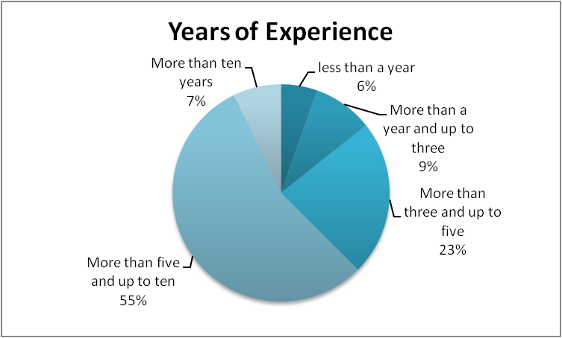
Figure 1. Graphical representation of the Sample.

2) Data Analysis: The variable contingency Planning was represented in the questionnaire by the questions from 1 to 5. And the variable Crisis Management was represented by the statements from 6 to 9. The last variable is Uncomfortable Work Environment and it was represented by the statements 12,13 and14.
The results showed that the mean of crisis Management (the calculated variable) is 3.2366 which is higher than the scale mean. a further analysis was conducted to test the statistical meaning of that result as following:

TABLE 5. One-Sample Test
 | Test Value = 2.5
 | t | Df | Sig. (2-tailed) | Mean Difference | 95% Confidence Interval of the Difference
 |  |  |  |  | Lower | Upper
Crisis Management | 5.619 | 55 | .000 | .73661 | .4739 | .9993

The test returns a positive result regarding the meaning of the mean. In other words, employees tend to believe that their management employ crisis management practices.

By analyzing the correlation between the Crisis Management and Contingency Planning, the analysis results indicate a strong correlation between the two variables.

TABLE 6. Correlations

 |  | Contingency Planning | Crisis Management
Contingency Planning | Pearson Correlation | 1 | .529**
 | Sig. (2-tailed) |  | .000
 | N | 56 | 56
Crisis Management | Pearson Correlation | .529** | 1
 | Sig. (2-tailed) | .000
 | N | 56 | 56
**. Correlation is significant at the 0.01 level (2-tailed).

The responses were positive about the hypothesis H2: Syrian banks has used crisis management to overcome the crisis situation. The mean of the responses related to Statement#7 was 3.28 which is higher than the mean of the scale. In order to test the trust in that mean we apply the one sample t-test analysis.
TABLE 7. One-Sample Test
 | Test Value = 2.5
 | t | Df | Sig. (2-tailed) | Mean Difference | 95% Confidence Interval of the Difference
 |  |  |  |  | Lower | Upper
Management designed procedure to prevent business crisis to happened. | 22.232 | 56 | .000 | 0.7807 | 0.4851 | 1.0763

The table shows the mean difference is statistically significant.

Also analyzing the answers for statement#8.

TABLE 8. One-Sample Test
 | Test Value = 0
 | t | Df | Sig. (2-tailed) | Mean Difference | 95% Confidence Interval of the Difference
 |  |  |  |  | Lower | Upper
Management pre-plan to deal with expected crisis | 21.161 | 56 | .000 | 3.21053 | 2.9066 | 3.5145

The results also show that the responders are positive towards the fact that the bank management plans in advance for the expected crisis.

Let’s move to analyze the variable of Uncomfortable Work Environment. The mean of this variable is: 4.2917 which is higher than the mean of the scale, this result represents that there is a positive trend among employees to think that their work environment is not comfortable. Table below support that result.

TABLE 9. One-Sample Test
 | Test Value = 2.5
 | t | Df | Sig. (2-tailed) | Mean Difference | 95% Confidence Interval of the Difference
 |  |  |  |  | Lower | Upper
Uncomfortable Work Environment | 18.150 | 55 | .000 | 1.79167 | 1.5938 | 1.9895

